MICROCONTROLLER
Microcontroller is the advanced version of microprocessors. A microcontroller is a small and low-cost microcomputer, which is designed to perform the specific tasks of embedded systems like displaying microwave’s information, receiving remote signals, etc.
It contain on chip Central Processing Unit (CPU), Read only memory (ROM), Random access memory (RAM), Input/Output unit, Interrupts Controller etc.
Therefore a microcontroller is used for high speed signal processing operation inside an embedded system. It acts as a major component used in designing of an embedded system.
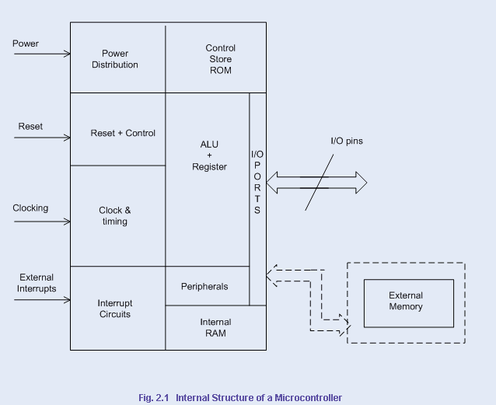
The basic components of microcontroller:
- Arithmetic and Logic Unit (ALU): ALU inside a microcontroller used to perform the arithmetic and logic operation. It performs the logic operation on the data stored inside a register.
- Accumulator: Accumulator is the register inside which the intermediate arithmetic and logical operation data is stored.
- I/O ports: I/O ports are used for connecting input devices like sensor, keyboard etc with input ports and output devices like LCD, buzzer etc with output ports available in microcontroller.
- Working registers: Registers are the storage device used to store the data inside a microcontroller in different address location.
- Program counter: Program counter is used for counting the number of program executed inside a microcontroller.
- Stack pointer: Stack pointer act as a pointer to the certain address. It is a register used to store the address of the last program request made by the processor inside a stack.
- Clock circuit: Clock circuit is used for generate the clock pulse required as a reference signal for the microcontroller.
- Interrupt circuit: Interrupt circuit is used for generating the interrupt signal when the higher priority process required to be served first on basis of priority by microcontroller.
- Internal ROM: Internal ROM is read only memory used to store the information in embedded system. It acts as a main memory for storing the instruction and data inside a microcontroller.

TYPES OF MICROCONTROLLERS
Microcontrollers are divided into various categories based on memory, architecture, bits and instruction sets. Following is the list of their types −

Bit
Based on bit configuration, the microcontroller is further divided into three categories.
- 8-bit microcontroller − This type of microcontroller is used to execute arithmetic and logical operations like addition, subtraction, multiplication division, etc. For example, Intel 8031 and 8051 are 8 bits microcontroller.
- 16-bit microcontroller − This type of microcontroller is used to perform arithmetic and logical operations where higher accuracy and performance is required. For example, Intel 8096 is a 16-bit microcontroller.
- 32-bit microcontroller − This type of microcontroller is generally used in automatically controlled appliances like automatic operational machines, medical appliances, etc.

Memory
Based on the memory configuration, the microcontroller is further divided into two categories.
- External memory microcontroller − This type of microcontroller is designed in such a way that they do not have a program memory on the chip. Hence, it is named as external memory microcontroller. For example: Intel 8031 microcontroller.
- Embedded memory microcontroller − This type of microcontroller is designed in such a way that the microcontroller has all programs and data memory, counters and timers, interrupts, I/O ports are embedded on the chip. For example: Intel 8051 microcontroller.

Instruction Set
Based on the instruction set configuration, the microcontroller is further divided into two categories.
- CISC − CISC stands for complex instruction set computer. It allows the user to insert a single instruction as an alternative to many simple instructions.
- RISC − RISC stands for Reduced Instruction Set Computers. It reduces the operational time by shortening the clock cycle per instruction.

Architecture
On the basis of architecture the types of microcontroller are:
- Havard Architecture
- Von Neumann Architecture
Havard Architecture: In Havard architecture separate storage and signal buses are provided for different set of instructions and data. This architecture has the entire data storage within the CPU and there is no access available for instruction storage as data.This architecture provides simultaneous access to an instructions and data stored inside internal buses of microcontroller.
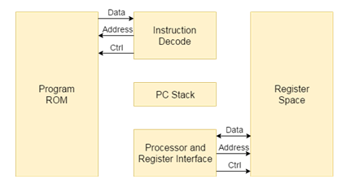

Von Neumann Architecture: This architecture of microcontroller was proposed by scientist John Von Neumann. In this architecture for both instruction and data a single data path or bus is present.Therefore the CPU performs a single operation at a time. It either performs Read/Write operation on data, or fetches a set of instruction from memory. Hence instruction fetch and a data transfer operation cannot occur simultaneously by using a common bus.
Block diagram of Von Neumann Architecture:

MICROPROCESSOR VS MICROCONTROLLER
A list of differences between Microprocessor and Microcontroller are given below.
S.No | Microprocessor | Microcontroller
1 | Microprocessor acts as a heart of computer system. | Microcontroller acts as a heart of embedded system.
2 | It is a processor in which memory and I/O output component is connected externally. | It is a controlling device in which memory and I/O output component is present internally.
3 | Since memory and I/O output is to be connected externally. Therefore the circuit is more complex. | Since on chip memory and I/O output component is available. Therefore the circuit is less complex.
4 | It cannot be used in compact system. Therefore microprocessor is inefficient. | It can be used in compact system. Therefore microcontroller is more efficient.
5 | A microprocessor having a zero status flag. | A microcontroller has no zero flag.
6 | It is mainly used in personal computers. | It is mainly used in washing machines, air conditioners etc.
7 | It doesn’t consist of RAM, ROM, I/O ports. It uses its pins to interface to peripheral devices. | It consists of CPU, RAM, ROM, I/O ports.
8 | Its power consumption is high because it has to control the entire system. | It is built with CMOS technology, which requires less power to operate.
10 | Microprocessors are used for big applications | Microcontrollers a10re used to execute a single task within an application.
11 | 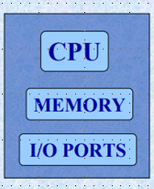 | 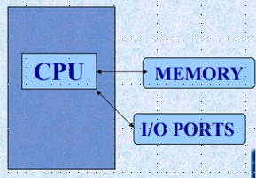

APPLICATIONS OF MICROCONTROLLERS
Microcontrollers are widely used in various different devices such as −
- Light sensing and controlling devices like LED.
- Temperature sensing and controlling devices like microwave oven, chimneys.
- Fire detection and safety devices like Fire alarm.
- Measuring devices like Volt Meter.

CRITERIA FOR SELECTING A MICROCONTROLLER

1.Know Hardware Requirements
The first thing to consider while choosing a microcontroller is to consider what hardware devices your project need. You must have an idea what hardware peripherals you need to connect with your microcontroller.
- Does your embedded system needs communication interfaces like UART?
- Does it needs Ethernet?
- How many output and input pins you need to connect?
- Does it needs USB port or other serial ports?
- Do you want PWM?
These are some questions to think. You can reduce your choices from a number of microcontrollers by considering the hardware requirements.

2.Know Software Requirements
Just as hardware of the project, you need to know the software required by your project. The software requirement is also important to consider.
- What processing speed is required?
- What type of calculations are involved?
- How much processing power is required?
- What are the timing constraints?
.
3.Architecture
The architecture of a microcontroller is the internal structure. When you have the idea about hardware and software requirements of the project, you can look for different type of microcontrollers to find the matching ones. They have a number of families and come in a variety of types that include 4 bit, 8 bit, 16 bit and 32 bit. 32 bit microcontrollers are the ones used in embedded systems.
4.Cost and Power Requirements
Cost factor is very important while developing a project or an embedded system. If you require complex functions and operations from your microcontroller, cost will be higher. If it is for a simple application, than a cheap microcontroller can serve the purpose.
Power required in your project should also be considered. If you are going to run your system on battery than consider the rating. Consider if your microcontroller meets the power or not.
5. Memory Requirement
The memory size is very serious issue to consider. How much memory is required by your code and How much RAM you need are worth considering. There should be some extra memory from estimated so you will not run short of space.
6.Search Microcontrollers
Up till this step, you have all the information required to start looking for microcontrollers. You can use online information available for different microcontrollers. Also, you can take help of some professional who can direct you to some family of microcontrollers. You will use your previous steps to filter from a wide variety. Search for new products available in the market so you can make better use of all the features.
7.Know Software Tools

Microcontrollers come with some standard software tools with them. These tools are provided by the manufacturers and are very useful. They come with assemblers, compilers, debuggers and simulating tools. So it is good to know about all the products available with the microcontroller.
8. Simulation Tools
It is good to use simulation software to check the working of microcontroller.
9. Start with Microcontroller kits
Microcontroller kits are very useful for starting your work.
While choosing a microcontroller, make sure it meets the task at hand and that it is cost effective.

INTEL 8051 MICRCONTROLLER :

The 8051 microcontroller is a very popular 8-bit microcontroller introduced by Intel in the year 1981 and it has become almost the academic standard now a days. The 8051 is based on an 8-bit CISC core with Harvard architecture. Its 8-bit architecture is optimized for control applications with extensive Boolean processing. It is available as a 40-pin DIP chip and works at +5 Volts DC. The salient features of 8051 controller are given below.
SALIENT FEATURES :
i. 4 KB on chip program memory (ROM or EPROM)).
ii. 128 bytes on chip data memory(RAM).
iii. 8-bit data bus
iv. 16-bit address bus
v. 32 general purpose registers each of 8 bits
vi. Two -16 bit timers T0 and T1
vii. Five Interrupts (3 internal and 2 external).
ix. Four Parallel ports each of 8-bits (PORT0, PORT1,PORT2,PORT3) with a total of 32 I/O
lines.
x. One 16-bit program counter and One 16-bit DPTR ( data pointer)
xi. One 8-bit stack pointer
xii. One Microsecond instruction cycle with 12 MHz Crystal.
xiii. One full duplex serial communication port.
ARCHITECTURE & BLOCK DIAGRAM OF 8051 MICROCONTROLLER:
It consists of an 8-bit ALU, one 8-bit PSW(Program Status Register), A and B registers , one 16-bit Program counter , one 16-bit Data pointer register(DPTR),128 bytes of RAM and 4kB of ROM and four parallel I/O ports each of 8-bit width.
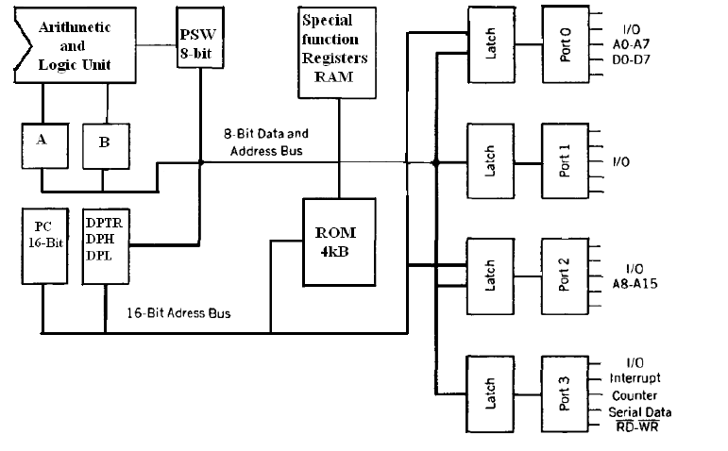
8051 has 8-bit ALU which can perform all the 8-bit arithmetic and logical operations in one machine cycle. The ALU is associated with two registers A & B
A and B Registers : The A and B registers are special function registers which hold the results of many arithmetic and logical operations of 8051.The A register is also called the Accumulator
and as it’s name suggests, is used as a general register to accumulate the results of a large number of instructions. By default it is used for all mathematical operations and also data transfer operations between CPU and any external memory.
The B register is mainly used for multiplication and division operations along with A register.
MUL AB : DIV AB.
It has no other function other than as a location where data may be stored.
The R registers: The "R" registers are a set of eight registers that are named R0, R1, etc. up to
and including R7. These registers are used as auxillary registers in many operations. The "R" registers are also used to temporarily store values.
Program Counter(PC) : 8051 has a 16-bit program counter .The program counter always points to the address of the next instruction to be executed. After execution of one instruction the program counter is incremented to point to the address of the next instruction to be executed.It is the contents of the PC that are placed on the address bus to find and fetch the desired instruction.Since the PC is 16-bit width ,8051 can access program addresses from 0000H to FFFFH ,a total of 6kB of code.
Stack Pointer Register (SP) : It is an 8-bit register which stores the address of the stack top. i.e the Stack Pointer is used to indicate where the next value to be removed from the stack should be taken from. When a value is pushed onto the stack, the 8051 first increments the value of SP and then stores the value at the resulting memory location. Similarly when a value is popped off the stack, the 8051 returns the value from the memory location indicated by SP, and then decrements the value of SP. Since the SP is only 8-bit wide it is incremented or decremented by two . SP is modified directly by the 8051 by six instructions: PUSH, POP, ACALL, LCALL, RET, and RETI. It is also used intrinsically whenever an interrupt is triggered.
STACK in 8051 Microcontroller : The stack is a part of RAM used by the CPU to store information temporarily. This information may be either data or an address .The CPU needs this storage area as there are only limited number of registers. The register used to access the stack is called the Stack pointer which is an 8-bit register..So,it can take values of 00 to FF H.When the 8051 is powered up ,the SP register contains the value 07.i.e the RAM location value 08 is the first location being used for the stack by the 8051 controller
There are two important instructions to handle this stack. One is the PUSH and the Other is the POP. The loading of data from CPU registers to the stack is done by PUSH and the loading of the contents of the stack back into a CPU register is done by POP.
EX : MOV R6 ,#35 H
MOV R1 ,#21 H
PUSH 6
PUSH 1
In the above instructions the contents of the Registers R6 and R1 are moved to stack and they occupy the 08 and 09 locations of the stack.Now the contents of the SP are incremented by two and it is 0A
Similarly POP 3 instruction pops the contents of stack into R3 register.Now the contents of the SP is decremented by 1
In 8051 the RAM locations 08 to 1F (24 bytes) can be used for the Stack.In any program if we need more than 24 bytes of stack ,we can change the SP point to RAM locations 30-7F H.this can be done with the instruction MOV SP,# XX.
Data Pointer Register(DPTR) : It is a 16-bit register which is the only user-accessible. DPTR, as the name suggests, is used to point to data. It is used by a number of commands which allow the 8051 to access external memory. When the 8051 accesses external memory it will access external memory at the address indicated by DPTR. This DPTR can also be used as two 8-registers DPH and DPL.
Program Status Register (PSW) : The 8051 has a 8-bit PSW register which is alsoknown as Flag register.In the 8-bit register only 6-bits are used by 8051.The two unused bits are user definable bits.In the 6-bits four of them are conditional flags .They are Carry –CY,Auxiliary Carry-AC, Parity-P,and Overflow-OV .These flag bits indicate some conditions that resulted after an instruction was executed.
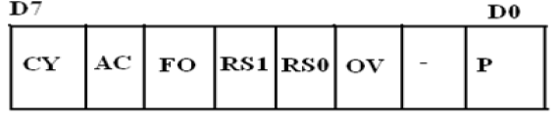
The bits PSW3 and PSW4 are denoted as RS0 and RS1 and these bits are used th select the bank registers of the RAM location. The meaning of various bits of PSW register is shown below.
CY PSW.7 Carry Flag
AC PSW.6 Auxiliary Carry Flag
FO PSW.5 Flag 0 available for general purpose .
RS1 PSW.4 Register Bank select bit 1
RS0 PSW.3 Register bank select bit 0
OV PSW.2 Overflow flag
--- PSW. User definable flag
P PSW.0 Parity flag .set/cleared by hardware
The selection of the register Banks and their addresses are given below.
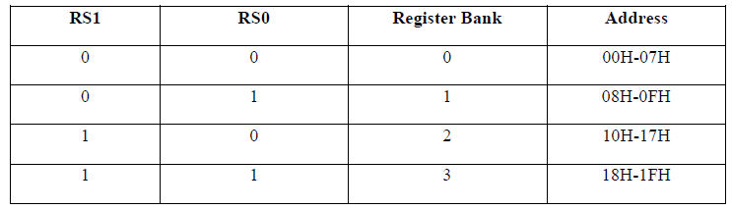
MEMORY ORGANIZATION :
The 8051 microcontroller has 128 bytes of Internal RAM and 4kB of on chip ROM .The RAM is also known as Data memory and the ROM is known as program memory. The program memory is also known as Code memory .This Code memory holds the actual 8051 program that is to be executed. In 8051 this memory is limited to 64K .Code memory may be found on-chip, as ROM or EPROM. It may also be stored completely off-chip in an external ROM or, more commonly, an external EPROM. The 8051 has only 128 bytes of Internal RAM but it supports 64kB of external RAM. As the name suggests, external RAM is any random access memory which is off-chip. Since the memory is off-chip it is not as flexible interms of accessing, and is also slower. For example, to increment an Internal RAM location by 1,it requires only 1 instruction and 1 instruction cycle but to increment a 1-byte value stored in External RAM requires 4 instructions and 7 instruction cycles. So, here the external memory is 7 times slower.
Internal RAM OF 8051 :
This Internal RAM is found on-chip on the 8051 .So it is the fastest RAM available, and it is also the most flexible in terms of reading, writing, and modifying it’s contents. Internal RAM is volatile, so when the 8051 is reset this memory is cleared. The 128 bytes of internal RAM is organized as below.
(i) Four register banks (Bank0,Bank1, Bank2 and Bank3) each of 8-bits (total 32 bytes). The default bank register is Bank0. The remaining Banks are selected with the help of RS0 and RS1 bits of PSW Register.
(ii) 16 bytes of bit addressable area and
(iii) 80 bytes of general purpose area (Scratch pad memory) as shown in the diagram below. This area is also utilized by the microcontroller as a storage area for the operating stack.

128 bytes of Internal RAM Structure (lower address space)
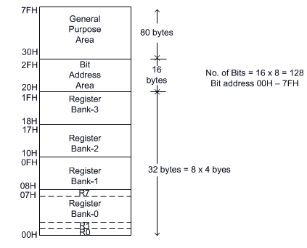
Internal RAM Structure

The 32 bytes of RAM from address 00 H to 1FH are used as working registers organized as four banks of eight registers each.The registers are named as R0-R7 .Each register can be addressed by its name or by its RAM address.
For EX : MOV A, R7 or MOV R7,#05H
Internal Data Memory and Special Function Register (SFR) Map
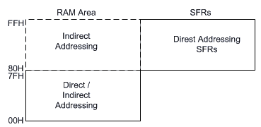
Fig : Internal Data Memory Map

Internal ROM (On –chip ROM):
The 8051 microcontroller has 4kB of on chip ROM but it can be extended up to 64kB.This ROM is also called program memory or code memory. The CODE segment is accessed using the program counter (PC) for opcode fetches and by DPTR for data. The external ROM is accessed when the EA(active low) pin is connected to ground or the contents of program counter exceeds 0FFFH.When the Internal ROM address is exceeded the 8051 automatically fetches the code bytes from the external program memory.
Interfacing External Memory
If external program/data memory are to be interfaced, they are interfaced in the following way.
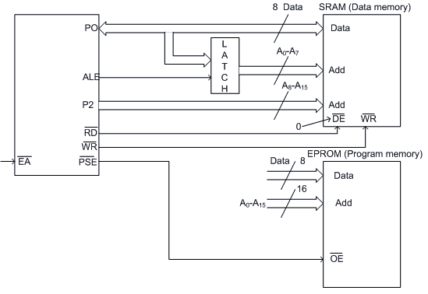
Fig : Circuit Diagram for Interfacing of External Memory
External program memory is fetched if either of the following two conditions are satisfied.
- (Enable Address) is low. The microcontroller by default starts searching for program from external program memory.
- PC is higher than FFFH for 8051 or 1FFFH for 8052.
tells the outside world whether the external memory fetched is program memory or data memory. is user configurable. is processor controlled.
Accessing external memory
Access to external program memory uses the signal (Program store enable) as the read strobe. Access to external data memory uses (alternate function of P3.7 and P3.6).
For external program memory, always 16 bit address is used. For example -
MOVC A, @ A+DPTR
MOVC A, @ A+PC
Access to external data memory can be either 8-bit address or 16-bit address -
8-bit address- MOVX A, @Rp where Rp is either R0 or R1
MOVX @Rp, A
16 bit address- MOVX A,@DPTR
MOV X @DPTR, A
The external memory access in 8051 can be shown by a schematic diagram as given in fig 7.1.
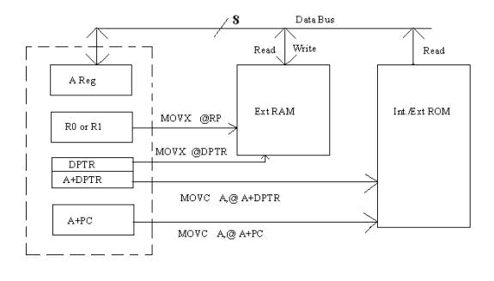
Fig Schematic diagram of external memory access
If an 8-bit external address is used for data memory (i.e. MOVX @Rp) then the content of Port-2 SFR remains at Port-2 pins throughout the external memory cycle. This facilitates memory paging as the upper 8 bit address remains fixed.
During any access to external memory, the CPU writes FFH to Port-0 latch (SFR). If the user writes to Port-0 during an external memory fetch, the incoming byte is corrupted.
External program memory is accessed under the following condition.
- Whenever is low, or
- Whenever PC contains a number higher than 0FFFH (for 8051) or 1FFF (for 8052).
Some typical use of code/program memory access:
External program memory can be not only used to store the code, but also for lookup table of various functions required for a particular application. Mathematical functions such as Sine, Square root, Exponential, etc. can be stored in the program memory (Internal or eternal) and these functions can be accessed using MOVC instruction.
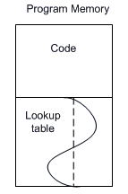
Fig Program memory showing the storage of lookup table

PIN Diagram of 8051 Microcontroller : The 8051 microcontroller is available as a 40 pin DIP chip and it works at +5 volts DC. Among the 40 pins , a total of 32 pins are allotted for the four parallel ports P0,P1,P2 and P3 i.e each port occupies 8-pins .The remaining pins are VCC, GND, XTAL1, XTAL2, RST, EA ,PSEN.
XTAL1,XTAL2: These two pins are connected to Quartz crystal oscillator which runs the on-chip oscillator. The quartz crystal oscillator is connected to the two pins along with a capacitor of 30pF as shown in the circuit. If we use a source other than the crystal oscillator, it will be connected to XTAL1 and XTAL2 is left unconnected.
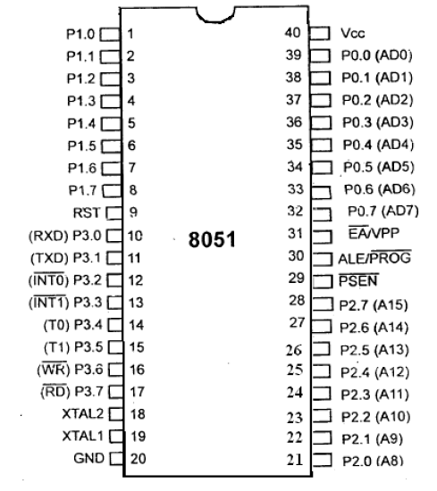
Pins 1 to 8 − These pins are known as Port 1. This port doesn’t serve any other functions.
Pin 9 − It is a RESET pin, which is used to reset the microcontroller to its initial values.
Pins 10 to 17 − These pins are known as Port 3. This port serves some functions like interrupts, timer input, control signals, serial communication signals RxD and TxD, etc.
Pins 18 & 19 − These pins are used for interfacing an external crystal to get the system clock.
Pin 20 − This pin provides the ground supply to the circuit.
Pins 21 to 28 − These pins are known as Port 2. It serves as I/O port. Higher order address bus signals are also multiplexed using this port.
Pin 29 − This is PSEN pin which stands for Program Store Enable. It is used to read a signal from the external program memory.
Pin 31 − This is EA pin which stands for External Access input. It is used to enable/disable the external memory interfacing.
Pin 30 − This is ALE pin which stands for Address Latch Enable. It is used to demultiplex the address-data signal of port.
Pins 32 to 39 − These pins are known as Port 0. It serves as I/O port. Lower order address and data bus signals are multiplexed using this port.
Pin 40 − This pin is used to provide power supply to the circuit.

ADDRESSING MODES OF 8051 :
The way in which the data operands are accessed by different instructions is known as the addressing modes. There are various methods of denoting the data operands in the instruction. The 8051 microcontroller supports mainly 5 addressing modes. They are
1.Immediate addressing mode
2.Direct Addressing mode
3.Register addressing mode
4. Register Indirect addressing mode
5.Indexed addressing mode
Immediate addressing mode : The addressing mode in which the data operand is a constant and it is a part of the instruction itself is known as Immediate addressing mode. Normally the data must be preceded by a # sign. This addressing mode can be used to transfer the data into any of the registers including DPTR.
Ex: MOV A , # 27 H : The data (constant) 27 is moved to the accumulator register
ADD R1 ,#45 H : Add the constant 45 to the contents of the accumulator
MOV DPTR ,# 8245H :Move the data 8245 into the data pointer register.
MOV P1,#21 H
Direct addressing mode: The addressing mode in which the data operand is in the RAM location (00 -7FH) and the address of the data operand is given in the instruction is known as Direct addressing mode. The direct addressing mode uses the lower 128 bytes of Internal RAM and the SFRs
MOV R1, 42H : Move the contents of RAM location 42 into R1 register
MOV 49H,A : Move the contents of the accumulator into the RAM location 49.
ADD A, 56H : Add the contents of the RAM location 56 to the accumulator
Register addressing mode :The addressing mode in which the data operand to be manipulated lies in one of the registers is known as register addressing mode.
MOV A,R0 : Move the contents of the register R0 to the accumulator
ADD A,R6 :Add the contents of R6 register to the accumulator
MOV P1, R2 : Move the contents of the R2 register into port 1
MOV R5, R2 : This is invalid .The data transfer between the registers is not allowed.
Register Indirect addressing mode :The addressing mode in which a register is used as a pointer to the data memory block is known as Register indirect addressing mode.
MOV A,@ R0 :Move the contents of RAM location whose address is in R0 into A (accumulator)
MOV @ R1 , B : Move the contents of B into RAM location whose address is held by R1
When R0 and R1 are used as pointers, they must be preceded by @ sign
Indexed addressing mode : This addressing mode is used in accessing the data elements of lookup table entries located in program ROM space of 8051.
Ex : MOVC A,@ A+DPTR
The 16-bit register DPTR and register A are used to form the address of the data element stored in on-chip ROM. Here C denotes code .In this instruction the contents of A are added to the 16-bit DPTR register to form the 16-bit address of the data operand.
SPECIAL FUNCTION REGISTERS(SFRs)
- In 8051 microcontroller there certain registers which uses the RAM addresses from 80h to FFh and they are meant for certain specific operations .These registers are called Special function registers (SFRs).Some of these registers are bit addressable also. There are 21 SFRs.
- In addition to I/O ports, the most frequently used SFRs to control and configure 8051 operations are:
  - TCON (Timer CONtrol)
  - TMOD (Timer MODe)
  - TH0/TH1 and TL0/TL1 (Timer’s high and low bytes)
  - SCON (Serial port CONtrol)
  - IP (Interrupt Priority)
  - IE ( Interrupt Enable)
Interrupt Enable Register :
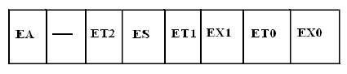
 EA : Global enable/disable. To enable the interrupts this bit must be set High.
 --- : Undefined-reserved for future use.
 ET2 : Enable /disable Timer 2 overflow interrupt.
 ES : Enable/disable Serial port interrupt.
 ET1 : Enable /disable Timer 1 overflow interrupt.
 EX1 : Enable/disable External interrupt1.
 ET0 : Enable /disable Timer 0 overflow interrupt.
 EX0 : Enable/disable External interrupt0

Upon reset the interrupts have the following priority.(Top to down). The interrupt with the highest PRIORITY gets serviced first.
Priority can also be set to ―high‖ or ―low‖ by 8-bit IP register.- Interrupt priority register
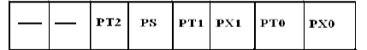
IP.7: reserved
IP.6: reserved
IP.5: Timer 2 interrupt priority bit (8052 only)
IP.4: Serial port interrupt priority bit
IP.3: Timer 1 interrupt priority bit
IP.2: External interrupt 1 priority bit
IP.1: Timser 0 interrupt priority bit
IP.0: External interrupt 0 priority bit
TIMERS in 8051 Microcontrollers : The 8051 microcontroller has two 16-bit timers Timer 0 (T0) and Timer 1(T1) which can be used either to generate accurate time delays or as event counters. These timers are accessed as two 8-bit registers TLO, THO & TL1 ,TH1 because the 8051 microcontroller has 8-bit architecture.
TIMER 0 : The Timer 0 is a 16-bit register and can be treated as two 8-bit registers (TL0 & TH0) and these registers can be accessed similar to any other registers like A,B or R1,R2,R3 etc…
Ex : The instruction Mov TL0,#07 moves the value 07 into lower byte of Timer0.
Similarly Mov R5,TH0 saves the contents of TH0 in the R5 register.
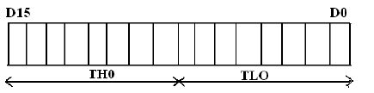
TIMER 1 : The Timer 1 is also a 16-bit register and can be treated as two 8-bit registers (TL1 & TH1) and these registers can be accessed similar to any other registers like A,B or R1,R2,R3 etc…
Ex : The instruction MOV TL1,#05 moves the value 05 into lower byte of Timer1.
Similarly MOV R0,TH1 saves the contents of TH1 in the R0 register
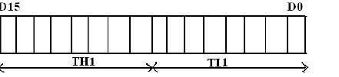
Timer Mode control (TMOD) Special Function Register:
TMOD register is not bit addressable.
TMOD
Address: 89 H
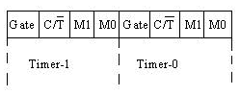
Various bits of TMOD are described as follows -
Gate: This is an OR Gate enabled bit which controls the effect of on START/STOP of Timer. It is set to one ('1') by the program to enable the interrupt to start/stop the timer. If TR1/0 in TCON is set and signal on pin is high then the timer starts counting using either internal clock (timer mode) or external pulses (counter mode).
It is used for the selection of Counter/Timer mode.
Mode Select Bits:
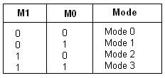
M1 and M0 are mode select bits.
Timer/ Counter control logic:
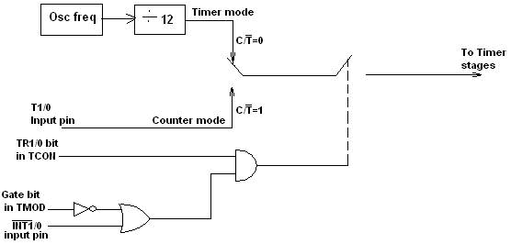
Fig 8.1 Timer/Counter Control Logic
Timer control (TCON) Special function register:
TCON is bit addressable. The address of TCON is 88H. It is partly related to Timer and partly to interrupt.
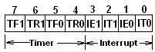
Fig 2 TCON Register
The various bits of TCON are as follows.
TF1 : Timer1 overflow flag. It is set when timer rolls from all 1s to 0s. It is cleared when processor vectors to execute ISR located at address 001BH.
TR1 : Timer1 run control bit. Set to 1 to start the timer / counter.
TF0 : Timer0 overflow flag. (Similar to TF1)
TR0 : Timer0 run control bit.
IE1 : Interrupt1 edge flag. Set by hardware when an external interrupt edge is detected. It is cleared when interrupt is processed.
IE0 : Interrupt0 edge flag. (Similar to IE1)
IT1 : Interrupt1 type control bit. Set/ cleared by software to specify falling edge / low level triggered external interrupt.
IT0 : Interrupt0 type control bit. (Similar to IT1)
As mentioned earlier, Timers can operate in four different modes. They are as follows
Timer Mode-0:
In this mode, the timer is used as a 13-bit UP counter as follows.
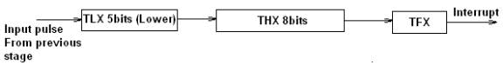
Fig. Operation of Timer on Mode-0
The lower 5 bits of TLX and 8 bits of THX are used for the 13 bit count.Upper 3 bits of TLX are ignored. When the counter rolls over from all 0's to all 1's, TFX flag is set and an interrupt is generated.
The input pulse is obtained from the previous stage. If TR1/0 bit is 1 and Gate bit is 0, the counter continues counting up. If TR1/0 bit is 1 and Gate bit is 1, then the operation of the counter is controlled by input. This mode is useful to measure the width of a given pulse fed to input.
Timer Mode-1:
This mode is similar to mode-0 except for the fact that the Timer operates in 16-bit mode.
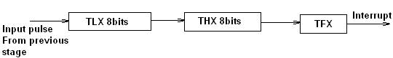
Fig Operation of Timer in Mode 1
Timer Mode-2: (Auto-Reload Mode)
This is a 8 bit counter/timer operation. Counting is performed in TLX while THX stores a constant value. In this mode when the timer overflows i.e. TLX becomes FFH, it is fed with the value stored in THX. For example if we load THX with 50H then the timer in mode 2 will count from 50H to FFH. After that 50H is again reloaded. This mode is useful in applications like fixed time sampling.
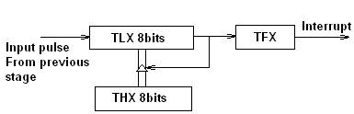
Fig Operation of Timer in Mode 2
Timer Mode-3:
Timer 1 in mode-3 simply holds its count. The effect is same as setting TR1=0. Timer0 in mode-3 establishes TL0 and TH0 as two separate counters.
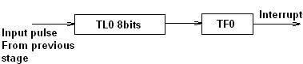
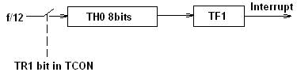
Fig Operation of Timer in Mode 3
Control bits TR1 and TF1 are used by Timer-0 (higher 8 bits) (TH0) in Mode-3 while TR0 and TF0 are available to Timer-0 lower 8 bits(TL0).

Timer Mode Register(TMOD)
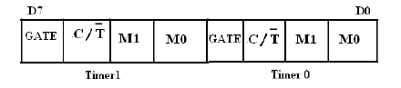
- GATE: This bit is used to start or stop the timers by hardware .When GATE= 1 ,the timers can be started / stopped by the external sources. When GATE= 0, the timers can be started or stopped by software instructions like SETB TR0 or SETB TR1
- C/T (clock/Timer) : C/T = 0 ,the Timer is used as delay generator and if C/T=1 the timer is used as an event counter.
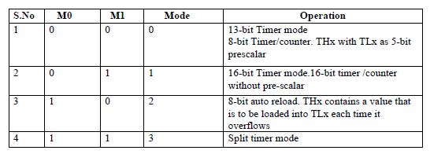
Timer Control Register(TCON)
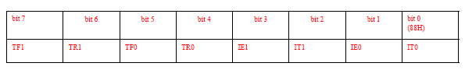
- TF0/TF1: Timer0/1 overflow flag is set when the timer/ counter overflows, reset by program
- TR0/TR1: Timer0/1 run control bit is set to start, reset to stop the timer0/1
- IE0/IE1: External Interrupt 0/1 edge detected flag: 1 is set when a falling edge interrupt on the external port 0/1.
- IT0/IT1 External Interrupt Type (1: falling edge triggered, 0 low level triggered)
PCON ( Power Control Register)
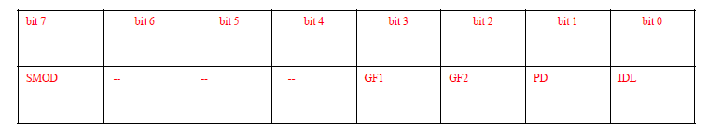
- SMOD(serial mode) 1= high baud rate, 0 = low baud rate
- • GF1, GF2 flags for free use
- • PD: 1= power down mode for CMOS
- • IDL: 1= idle mode.

SCON ( Serial Port Control Register)
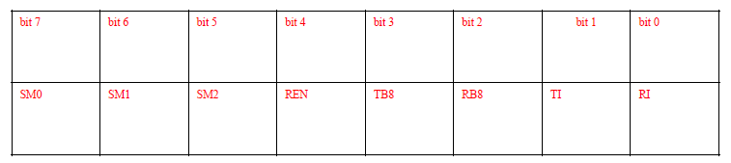
- REN: Receiver enable is set/reset by program
- TB8: stores transmitted bit 8(9th bit, the stop bit)
- RB8: Stores received bit 8(9th bit, the stop bit)
- TI: Transmit Interrupt is set at the end of 8th bit (mode 0) or at the stop bit (other modes) indicating the completion of one byte transmission, reset by program
• RI: Receive Interrupt is set at the end of 8th bit (mode 0) or at the stop bit (other modes) indicating the completion of one byte receiving, reset by program
- RI and TI flag in SCON SFR are used to detect the interrupt events.
If RI = 1 then a byte is received at the RxD pin. If TI = 1 then a byte is
- transmitted from the TxD pin.
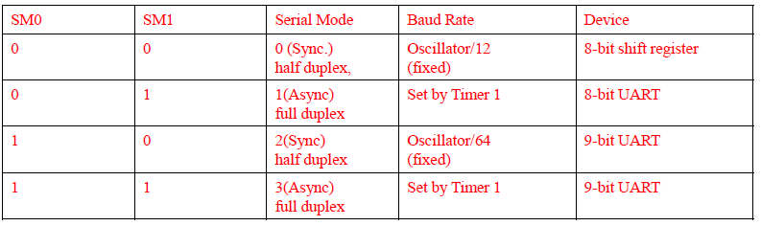
INTERRUPTS IN 8051
Interrupt Structure: An interrupt is an external or internal event that disturbs the microcontroller to inform it that a device needs its service. The program which is associated with the interrupt is called the interrupt service routine (ISR) or interrupt handler. Upon receiving the interrupt signal the Microcontroller , finish current instruction and saves the PC on stack. Jumps to a fixed location in memory depending on type of interrupt Starts to execute the interrupt service routine until RETI (return from interrupt)Upon executing the RETI the microcontroller returns to the place where it was interrupted. Get pop PC from stack
The 8051 microcontroller has FIVE interrupts in addition to Reset. They are

• Timer 0 overflow Interrupt
• Timer 1 overflow Interrupt
• External Interrupt 0(INT0)

• External Interrupt 1(INT1)
• Serial Port events (buffer full, buffer empty, etc) Interrupt

Out of these, and are external interrupts whereas Timer and Serial port interrupts are generated internally. The external interrupts could be negative edge triggered or low level triggered. All these interrupt, when activated, set the corresponding interrupt flags. Except for serial interrupt, the interrupt flags are cleared when the processor branches to the Interrupt Service Routine (ISR). The external interrupt flags are cleared on branching to Interrupt Service Routine (ISR), provided the interrupt is negative edge triggered. For low level triggered external interrupt as well as for serial interrupt, the corresponding flags have to be cleared by software by the programmer.
The schematic representation of the interrupts is as follows –
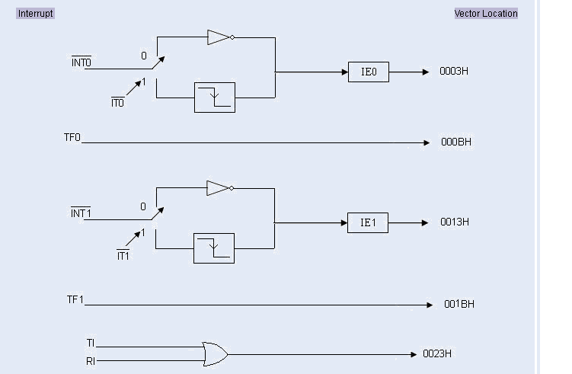

Each interrupt has a specific place in code memory where program execution (interrupt service routine) begins.
• External Interrupt 0: 0003 H
• Timer 0 overflow: 000B H
• External Interrupt 1: 0013 H
• Timer 1 overflow: 001B H
• Serial Interrupt : 0023 H
Priority level structure:
Each interrupt source can be programmed to have one of the two priority levels by setting (high priority) or clearing (low priority) a bit in the IP (Interrupt Priority) Register . A low priority interrupt can itself be interrupted by a high priority interrupt, but not by another low priority interrupt. If two interrupts of different priority levels are received simultaneously, the request of higher priority level is served. If the requests of the same priority level are received simultaneously, an internal polling sequence determines which request is to be serviced. Thus, within each priority level, there is a second priority level determined by the polling sequence, as follows.
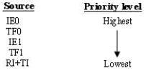
Interrupt handling:
The interrupt flags are sampled at P2 of S5 of every instruction cycle (Note that every instruction cycle has six states each consisting of P1 and P2 pulses). The samples are polled during the next machine cycle (or instruction cycle). If one of the flags was set at S5P2 of the preceding instruction cycle, the polling detects it and the interrupt process generates a long call (LCALL) to the appropriate vector location of the interrupt. The LCALL is generated provided this hardware generated LCALL is not blocked by any one of the following conditions.
- An interrupt of equal or higher priority level is already in progress.
- The current polling cycle is not the final cycle in the execution of the instruction in progress.
- The instruction in progress is RETI or any write to IE or IP registers.
When an interrupt comes and the program is directed to the interrupt vector address, the Program Counter (PC) value of the interrupted program is stored (pushed) on the stack. The required Interrupt Service Routine (ISR) is executed. At the end of the ISR, the instruction RETI returns the value of the PC from the stack and the originally interrupted program is resumed.
Reset is a non-maskable interrupt. A reset is accomplished by holding the RST pin high for at least two machine cycles. On resetting the program starts from 0000H and some flags are modified as follows -
The schematic diagram of the detection and processing of interrupts is given as follows.
Instruction Cycles
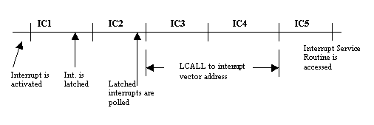
Fig Interrupt Handling in 8051
It should be noted that the interrupt which is blocked due to the three conditions mentioned before is not remembered unless the flag that generated interrupt is not still active when the above blocking conditions are removed, i.e. ,every polling cycle is new.

STACK IN THE 8051
- stack is a section of RAM used by the CPU to store information temporarily.
- this information could be data or an address.
- the register used to access the stack is called the SP (stack pointer) register.
- the stack pointer in the 8051 is only 8 bits wide, which means that it can take values of 00 to FFH.
- When the 8051 is powered up, the SP register contains value 07.
- This means that RAM location 08 is the first location used for the stack by the 8051.
PUSHING DATA ONTO THE STACK
- the stack pointer (SP) points to the last used location of the stack.
- as data is pushed onto the stack, the stack pointer (SP) is incremented by one.
- as each PUSH is executed, the contents of the register are saved on the stack and SP is incremented by 1.
- to push the registers onto the stack their RAM addresses should be used.
- For example, the instruction “PUSH 1″ pushes register Rl onto the stack.

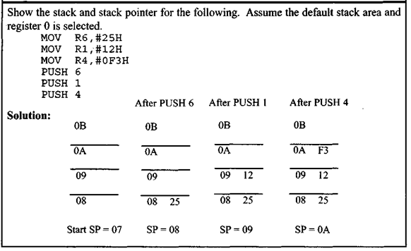
POPPING FROM THE STACK
- Popping the contents of the stack back into a given register is the opposite process of pushing.
- With every pop, the top byte of the stack is copied to the register specified by the instruction and the stack pointer is decremented once

